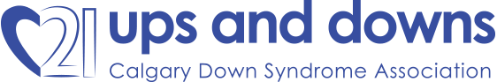
Street Meet 2022
Pledge Form
(PLEASE PRINT)
IMPORTANT: Cash or Cheques are to be kept in an envelope and all sponsor information recorded. This envelope, with all pledges inside, is to be submitted on or before the date of Street Meet. All amounts over $20.00 are eligible for a tax receipt; please indicate if one is required by checking the appropriate box.

Return envelope on event day or to:

Ups and Downs
Kensington RPO, Box 61180
Calgary, AB T2N 4S6

Or donate online at Street Meet Event 2022 - Ups and Downs (upsdowns.org)
PARTICIPANT NAME: ___________________________________
ADDRESS: ___________________________________________
___________________________________________
___________________________________________
PHONE: ___________________________
I AM SPONSORING: _______________________________________
(Name of individual with Down syndrome)

 | Sponsor’s Name | Address | City | Postal Code | Tax Receipt | Amount
1
2
3
4
5
6
7
8
9
10
11
12
13
14
15
16
17
18
19
20
 |  |  |  |  | TOTAL

